

Practices for Secure Software Report

Table of Contents
Document Revision History 3
Client 3
Instructions 3
Developer 4
1. Algorithm Cipher 4
2. Certificate Generation 4
3. Deploy Cipher 4
4. Secure Communications 4
5. Secondary Testing 4
6. Functional Testing 4
7. Summary 4
8. Industry Standard Best Practices 4

Document Revision History

Version | Date | Author | Comments
1.0 | 02/27/2026 | Allan Torres | VS CODE (GPT-5.3-Codex)

Client



Instructions

Submit this completed practices for secure software report. Replace the bracketed text with the relevant information. You must document your process for writing secure communications and refactoring code that complies with software security testing protocols.

- Respond to the steps outlined below and include your findings.
- Respond using your own words. You may also choose to include images or supporting materials. If you include them, make certain to insert them in all the relevant locations in the document.
- Refer to the Project Two Guidelines and Rubric for more detailed instructions about each section of the template.

Developer
[Insert your name here.]

Algorithm Cipher

The recommended approach is to use TLS for transport encryption and SHA-256 for checksum verification. TLS (HTTPS) protects data in transit between browser and server, while SHA-256 provides integrity verification for transferred data.

SHA-256 is a cryptographic hash function in the SHA-2 family that produces a 256-bit digest. It is one-way, deterministic, and resistant to collisions for practical use in application-layer integrity checks. In this project, the server computes the digest for an input string and returns the checksum so transmitted data can be verified.

For key usage, TLS uses asymmetric cryptography (public/private key certificate) to establish secure sessions and then uses symmetric session keys for efficient encrypted communication. Random numbers are critical in TLS handshake operations to generate nonces and session secrets. This hybrid model combines strong authentication and confidentiality with performance.

Historically, weak algorithms (for example MD5 and SHA-1 for integrity use cases) have known collision weaknesses and are no longer preferred for secure systems. Current best practice is SHA-256 or stronger hash functions and modern TLS with valid certificates.

Certificate Generation

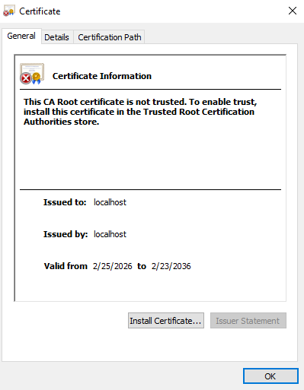

Deploy Cipher

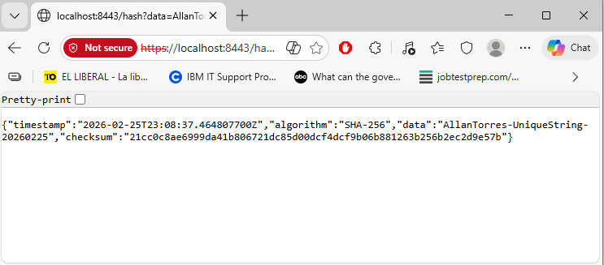

Secure Communications

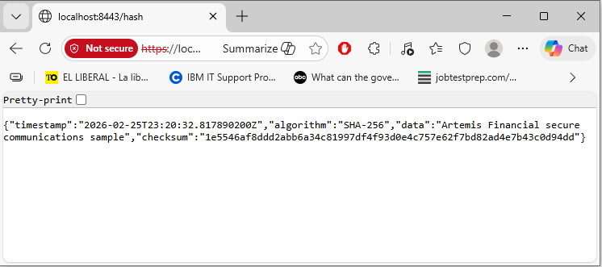

Secondary Testing

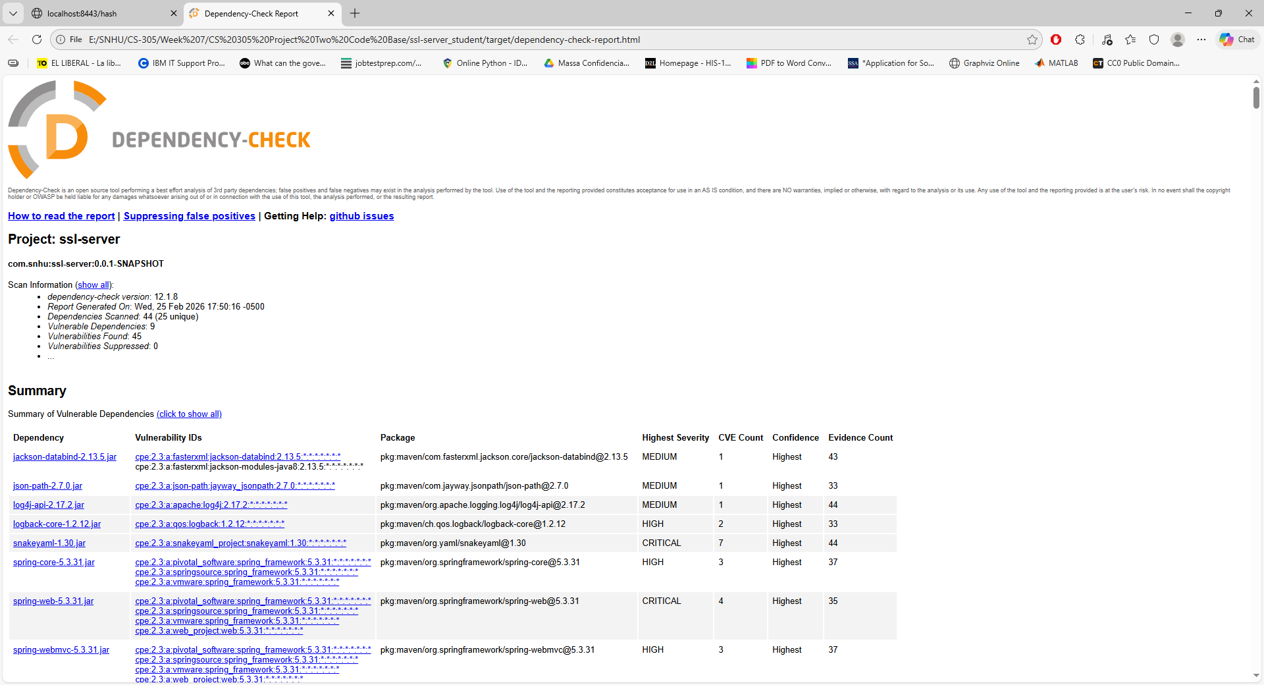

Functional Testing

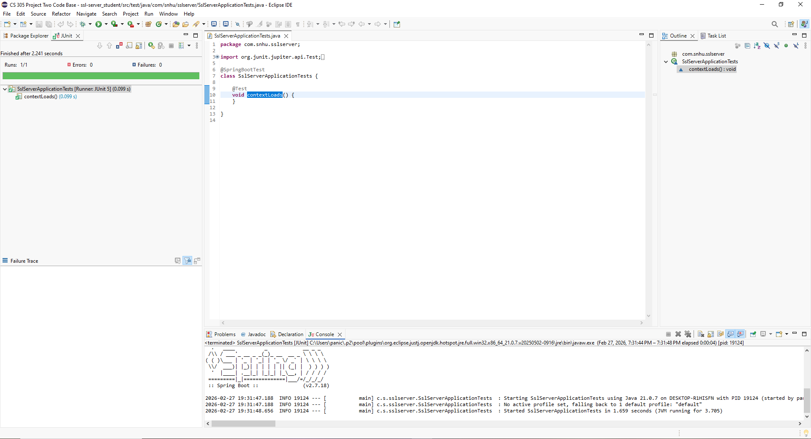

Summary

The application was refactored to add defense-in-depth for secure communications and integrity validation. The architecture and communication layers were improved by enabling HTTPS/TLS with a self-signed certificate and keystore. The cryptography area was strengthened by implementing SHA-256 checksum generation for transferred data.

Using the vulnerability assessment flow, the major addressed areas were:
- Architecture review: identified missing secure transport and integrity-check mechanism
- Cryptography: implemented SHA-256 checksum generation
- Client/Server: enforced HTTPS communication over TLS
- Code quality and code review: added clear endpoint behavior and error handling for checksum creation
- Secondary testing: executed dependency and validation checks to confirm no newly introduced critical issues

Security was layered by combining transport security (TLS), certificate-based identity, and payload integrity verification (SHA-256). This reduces risk of interception/tampering and improves trust in data exchanges.

Industry Standard Best Practices

Industry standards applied included:
- Use of TLS/HTTPS for encrypted in-transit data
- Use of modern hash algorithm (SHA-256) for integrity verification
- Principle of least exposure by implementing only required endpoint behavior
- Secure defaults in configuration (dedicated keystore, explicit TLS settings)
- Automated validation via build/test/security scanning tools

These practices preserve and improve existing application security by reducing common vulnerabilities (plaintext transport, weak integrity checks, unmanaged crypto configuration). For Artemis Financial, this improves confidentiality, integrity, and stakeholder trust while supporting compliance-oriented development expectations.

